THE USA AND THE WORLD FROM 1945 TO 2003

INTRODUCTION: a superpower taking roots in the course of 20th century
American foreign policy – between warmongering and diplomatic relationships
Diplomacy: profession, activity, or skill of managing international relations, typically by a country’s representatives abroad

I. A BIPOLAR WORLD IN THE COLD WAR (1946-1989)

A. CONTAINING COMMUNISM (1946-1953)

Document 1: Soviet take over in Europe, seen from the USA (www.johndclare.net)

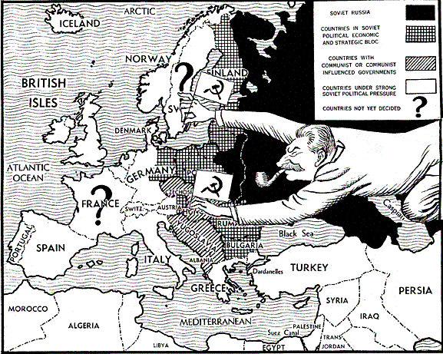

Document 2: British caricature on the first Berlin Crisis, by Illingworth – Daily Mail, 9 september 1948

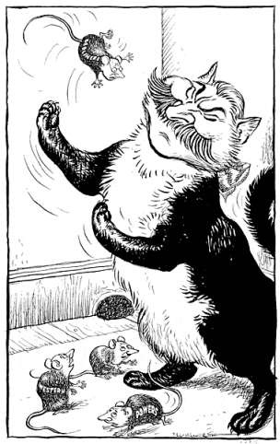

B. A PEACEFUL COEXISTENCE LEADING TO THE DÉTENTE (1953-1975)
Document 1: Dr. Khrushchev initiating a Détente with the USA, by Valtman (1962)

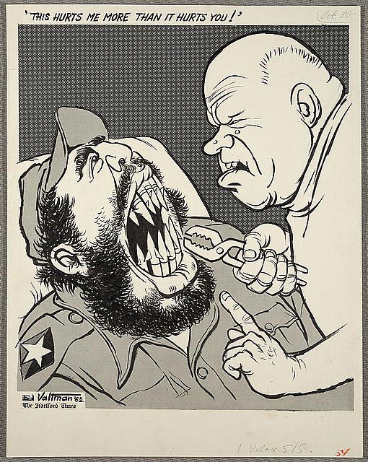

Document 2: The American foreign policy, seen by a dissident preacher
This speech is not addressed to Hanoi or to the National Liberation Front. It is not addressed to China or to Russia. Nor is it an attempt to overlook the ambiguity of the total situation and the need for a collective solution to the tragedy of Vietnam. Neither is it an attempt to make North Vietnam or the National Liberation Front paragons of virtue, nor to overlook the role they must play in the successful resolution of the problem. While they both may have justifiable reasons to be suspicious of the good faith of the United States, life and history give eloquent testimony to the fact that conflicts are never resolved without trustful give and take on both sides. Tonight, however, I wish not to speak with Hanoi and the National Liberation Front, but rather to my fellow Americans. (…) I knew that America would never invest the necessary funds or energies in rehabilitation of its poor so long as adventures like Vietnam continued to draw men and skills and money like some demonic, destructive suction tube. So I was increasingly compelled to see the war as an enemy of the poor and to attack it as such.
Martin Luther King, « Beyond Vietnam », New York, 4 April 1967

C. FROM DETERIORATING RELATIONS TO A NEW DÉTENTE (1975-1989)
Document 1: The Camp David Accords - Answar El Sadat, Menachem Begin and Jimmy Carter on September 1978
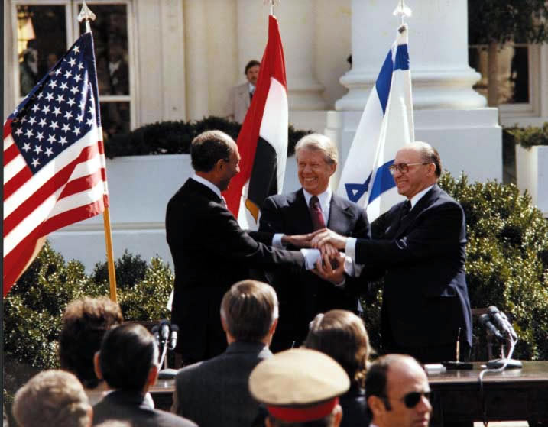

Document 2: Nixon and Mao: The week that changed the world, by Margaret Macmillan
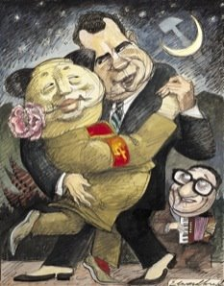
Document 3: Reagan’s policy concerning Afghanistan
In December 1979, the Soviet Union invaded Afghanistan without provocation and with overwhelming force. Since that time, the Soviet Union has sought through every available means, to assert its control over Afghanistan.
The Afghan people have defied the Soviet Union and have resisted with a vigor that has few parallels in modern history. The Afghan people have paid a terrible price in their fight for freedom. Their villages and homes have been destroyed; they have been murdered by bullets, bombs and chemical weapons. One-fifth of the Afghan people have been driven into exile. Yet their fight goes on. The international community, with the United States joining governments around the world, has condemned the invasion of Afghanistan as a violation of every standard of decency and international law and has called for a withdrawal of the Soviet troops from Afghanistan. Every country and every people has a stake in the Afghan resistance, for the freedom fighters of Afghanistan are defending principles of independence and freedom that form the basis of global security and stability.
It is therefore altogether fitting that the European Parliament, the Congress of the United States and parliaments elsewhere in the world have designated March 21, 1982, as Afghanistan Day, to commemorate the valor of the Afghan people and to condemn the continuing Soviet invasion of their country. Afghanistan Day will serve to recall not only these events, but also the principles involved when a people struggles for the freedom to determine its own future, the right to be free of foreign interference and the right to practice religion according to the dictates of conscience.
Now, Therefore, I, Ronald Reagan, President of the United States of America, do hereby designate March 21, 1982, as Afghanistan Day.
In Witness Whereof, I have hereunto set my hand this tenth day of March, in the year of our Lord nineteen hundred and eighty-two, and of the Independence of the United States of America the two hundred and sixth.
Ronald Reagan, Proclamation on the Soviet Invasion of Afghanistan, March 10, 1982

II. FAILURE OF THE EASTERN BLOC AND UNIPOLARITY (1989-2001)

- THE COLLAPSE OF PEOPLE’S DEMOCRACIES AND THE USSR (1989-1991)
Document 1: The end of USSR by Fred Valtman (1991)

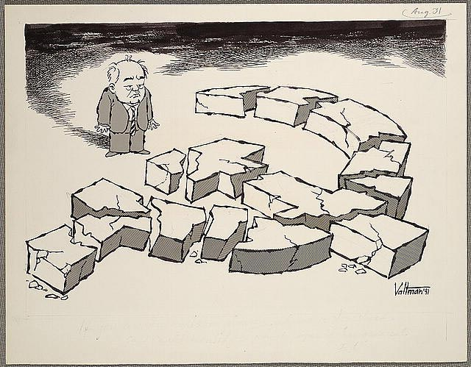

- US SUPERPOWER SEEN AS A “GLOBAL POLICEMAN” IN AN UNSTABLE NEW WORLD (1991-2001)
Document 1: Dayton agreements about the situation in Yugoslavia
Wright-Patterson Air Force Base, Ohio
November 21,1995

Excellency,
I refer to the Agreement on the Military Aspects of the Peace Settlement, which the Federal Republic of Yugoslavia has endorsed, and the Agreement Between the Republic of Bosnia and Herzegovina and the North Atlantic Treaty Organization (NATO) Concerning the Status of NATO and its Personnel. On behalf of the Federal Republic of Yugoslavia, I wish to assure you that the Federal Republic of Yugoslavia shall take all necessary steps, consistent with the sovereignty, territorial integrity and political independence of Bosnia and Herzegovina, to ensure that the Republika Srpska fully respects and complies with commitments to NATO, including in particular access and status of forces, as set forth in the aforementioned Agreements.
Slobodan Milosevic

His Excellency
Sergio Silvio Balanzino
Acting Secretary General
Norm Atlantic Treaty Organisation
1110 BRUSSELS
Belgium

GENERAL ASSEMBLY Fiftieth session
SECURITY COUNCIL Fiftieth year
Agenda item 28
“The Situation In Bosnia And Herzegovina”
A/50/790
S/1995/999
p.31
30 November 1995

www.peacemaker.un.org

Document 2: A Humanitarian Imperialism, according to Chomsky
As the Cold War ended, new pretexts had to be devised. George Bush celebrated the fall of the Berlin Wall by invading Panama, installing the regime of a tiny minority of bankers and narcotraffickers who, as predicted, have turned Panama into the second most active center for cocaine money laundering in the Western Hemisphere, the State Department concedes, the United States still holding first place. The Red Menace having disappeared, he was protecting us from Hispanic narcotraffickers led by the arch-demon Noriega, transmuted from valued friend to reincarnation of Attila the Hun, in standard fashion, when he began to disobey orders. And we were soon to learn that in the Middle East, long the major target of our intervention forces, the "threats to our interests . . . could not be laid at the Kremlin's door" (Bush National Security Strategy Report, March 1990); after decades of deception, the Soviet pretext can no longer be dredged up to justify traditional Pentagon-based industrial policy and intervention forces (…). Elliott Abrams noted that for the first time, the United States could intervene without concern for a Soviet reaction anywhere.
Noam Chomsky, « Humanitarian Intervention » in Boston Review, December, 1993-January, 1994

III. TOWARDS A MULTIPOLAR DISORDER? (SINCE 2001)

- THE TURNING POINT OF 9/11: THE USA CONFRONTED TO NEW THREATS

Document 1: War on terror, Cox and Forkum, 2001

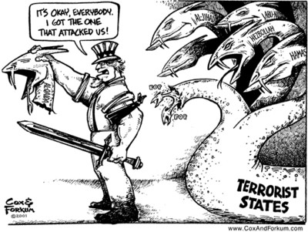

Document 2: “Winning the war on terror”
The American flag flies again over our embassy in Kabul. Terrorists who once occupied Afghanistan now occupy cells at Guantanamo Bay. And terrorist leaders who urged followers to sacrifice their lives are running for their own. America and Afghanistan are now allies against terror. We'll be partners in rebuilding that country […].
Our progress is a tribute to the spirit of the Afghan people, to the resolve of our coalition, and to the might of the United States military. When I called our troops into action, I did so with complete confidence in their courage and skill. And tonight, thanks to them, we are winning the war on terror. The man and women of our Armed Forces have delivered a message now clear to every enemy of the United States: Even 7,000 miles away, across oceans and continents, on mountaintops and in caves -- you will not escape the justice of this nation.
For many Americans, these four months have brought sorrow, and pain that will never completely go away. Every day a retired firefighter returns to Ground Zero, to feel closer to his two sons who died there. At a memorial in New York, a little boy left his football with a note for his lost father: Dear Daddy, please take this to heaven. I don't want to play football until I can play with you again someday.
George W. Bush, State of the Union Address, January 29th, 2002.

- US FOREIGN POLICY LED BY UNILATERALISM
Document 1: War on terror or mass distraction? by Nick Anderson, 2002

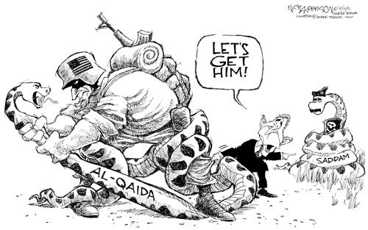

Document 2: Axis of Evil: “the Bush vision versus the End of History”
This process does not comport well with Francis Fukayama's vision of the new peaceful, democratic order that would follow the death of the Soviet Union and triumph of capitalism.
Fukayama […] failed to recognize that without the Soviet Union's "containment" the United States would be freer to use force in serving its transnationals, forcing Third World countries to join the "free trade" nexus, and preventing them from serving the needs of their citizens (as opposed to the needs of the transnational corporate community). […]
What can be more frightening and dangerous to the world than facing the Washington Axis of Evil as the overwhelmingly dominant holder of "weapons of mass destruction," which it is seeking to improve and make more usable, with the elite's longstanding arrogance and self-righteousness at an all-time high, and with no countervailing force in sight? Bin Laden's threat is nothing by comparison.
What is more, the Bin Laden threat flows from U.S. actions, which played a crucial role in building up the Al-Qaeda network, and policies which have made a hell of the Middle East and polarized incomes and wealth across the globe. The cycle of violence will only be broken if the Washington Axis of Evil is defeated, removed from office, and replaced by a regime that aims to serve a broader constituency than oil, the MIC, the other transnationals, and the Christian Right.
Professor Edward S. Herman, Z Magazine

CONCLUSION: A necessity of multilateralism? (increasing contests against the USA, and emerging counter-powers)
“Manufacturing consent” expression used by Walter Lipmann (author of “the Cold War”) and by Noam Chomsky since 1992 in order to denounce the way the media are used to justify political choices, etc.

Caricature by Nick Anderson, 9 March 2003
