NEW YORK: A GLOBAL CITY

INTRODUCTION: what is a global city?

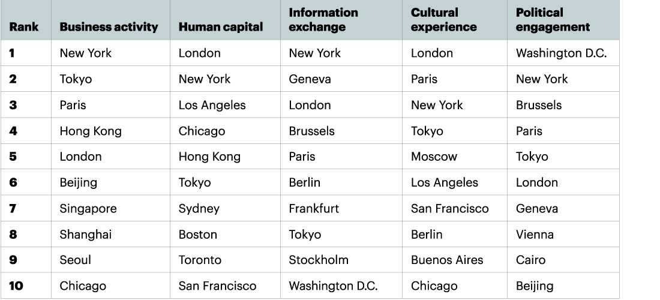

Razeen Sally, a visiting associate professor at the Lee Kuan Yew School of Public Policy, wrote this year in Singapore’s Straits Times that: “A global city is where truly global services cluster. Business — in finance, the professions, transport and communications — is done in several languages and currencies, and across several time zones and jurisdictions. Such creations face a unique set of challenges in the early 21st century. Today, there appear to be only five global cities. London and New York are at the top, followed by Hong Kong and Singapore, Asia’s two service hubs. Dubai, the Middle East hub, is the newest and smallest kid on the block. Shanghai has global-city aspirations, but it is held back by China’s economic restrictions — the vestiges of an ex-command economy — and its Leninist political system. Tokyo remains too Japan-centric, a far cry from a global city.”

I. COMMAND FUNCTIONS CONCENTRATED IN NEW YORK

A. AN INTERNATIONAL METROPOLIS

Document 1: New York City’s Growing High-Tech Industry www.osc.state.ny.us

In New York City, these high-tech companies have been flourishing, creating a source of well-paying jobs at a time when employment in many other traditionally well-paying industries has not been growing as quickly. […]
The high-tech industry’s young, creative workforce is attracted to New York City because of its culture, diversity, public transportation system and the opportunities it offers to live and work in the same community. World-class academic institutions and creative industries also draw people to New York City, providing new ideas and talent for the industry. Another benefit of locating in New York City is access to many sources of capital. The New York State Common Retirement Fund is taking an active role, making profitable investments in New York City’s technology industry that have helped companies expand and create new jobs. The high-tech industry is creating well-paying jobs and diversifying the local economy, which is helping to reduce New York City’s economic dependence on Wall Street.

Thomas P. DiNapoli, Kenneth B. Bleiwas, New York State Comptroller Deputy Comptroller – April 2014 (Report 2-2015)

Document 2: “Immigration and New York’s Resurgence” - Immigration and New York City: The Contributions of Foreign–Born Americans to New York’s Renaissance, 1975–2013 (Americas Society/Council of the Americas)

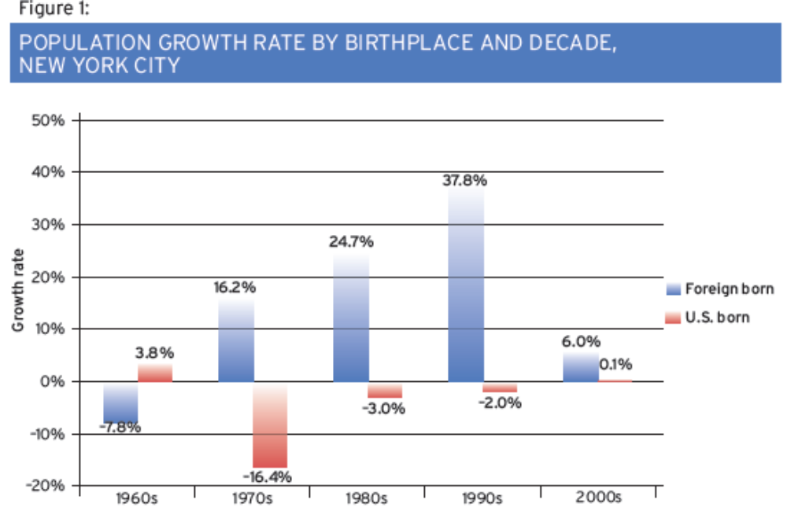

B. THE FIRST ECONOMIC AND FINANCIAL CENTER IN THE WORLD

Document 1: “Cities must be cool, creative and in control” (www.ft.com)Loading data...
A recent study commissioned by Citigroup and conducted by the Economist Intelligence Unit found New York City to be the most competitive city in the world. […]
For cities to have sustained success, they must compete for the grand prize: intellectual capital and talent. I have long believed that talent attracts capital far more effectively and consistently than capital attracts talent. The most creative individuals want to live in places that protect personal freedoms, prize diversity and offer an abundance of cultural opportunities. A city that wants to attract creators must offer a fertile breeding ground for new ideas and innovations. […]
In New York, for example, one of our most ambitious efforts has been a competition among world-class universities to build a new applied science and engineering campus. The first winner, a partnership between Cornell University and the Technion-Israel Institute of Technology, was selected in December. We expect the campus, set to convene its first classes this autumn, to spin off hundreds of start-ups from the school’s research and generate billions of dollars in economic activity. Economic development projects on this scale should not be the preserve of the nation state.
Michael Bloomberg, mayor of New York,taken from The Financial Times, March 27, 2012

Document 2: Times Square, “Center of the Universe”

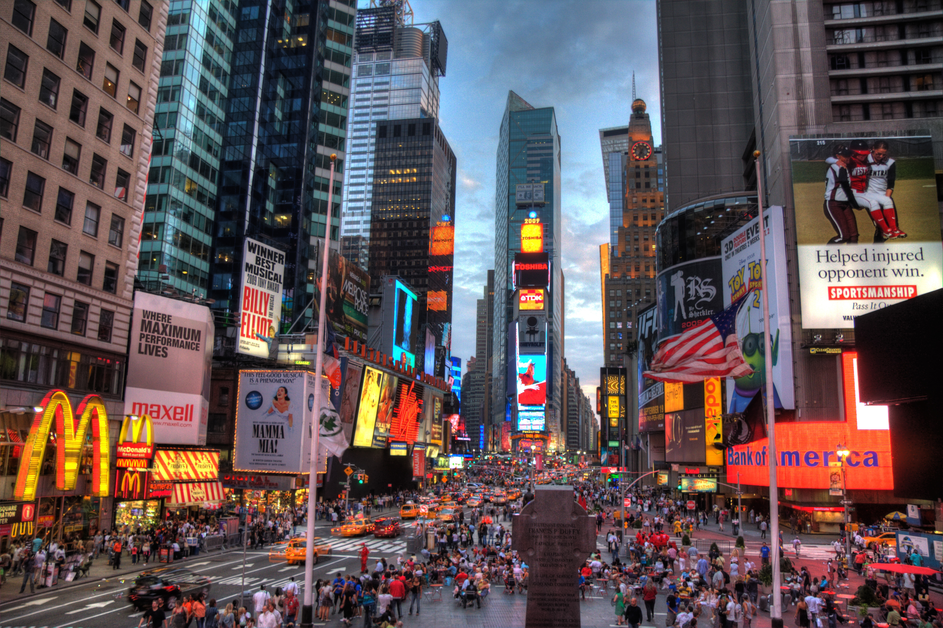

C. THE CAPITAL FOR CULTURE AND TOURISM
Document 1: Entertainment industries (a view from Broadway)

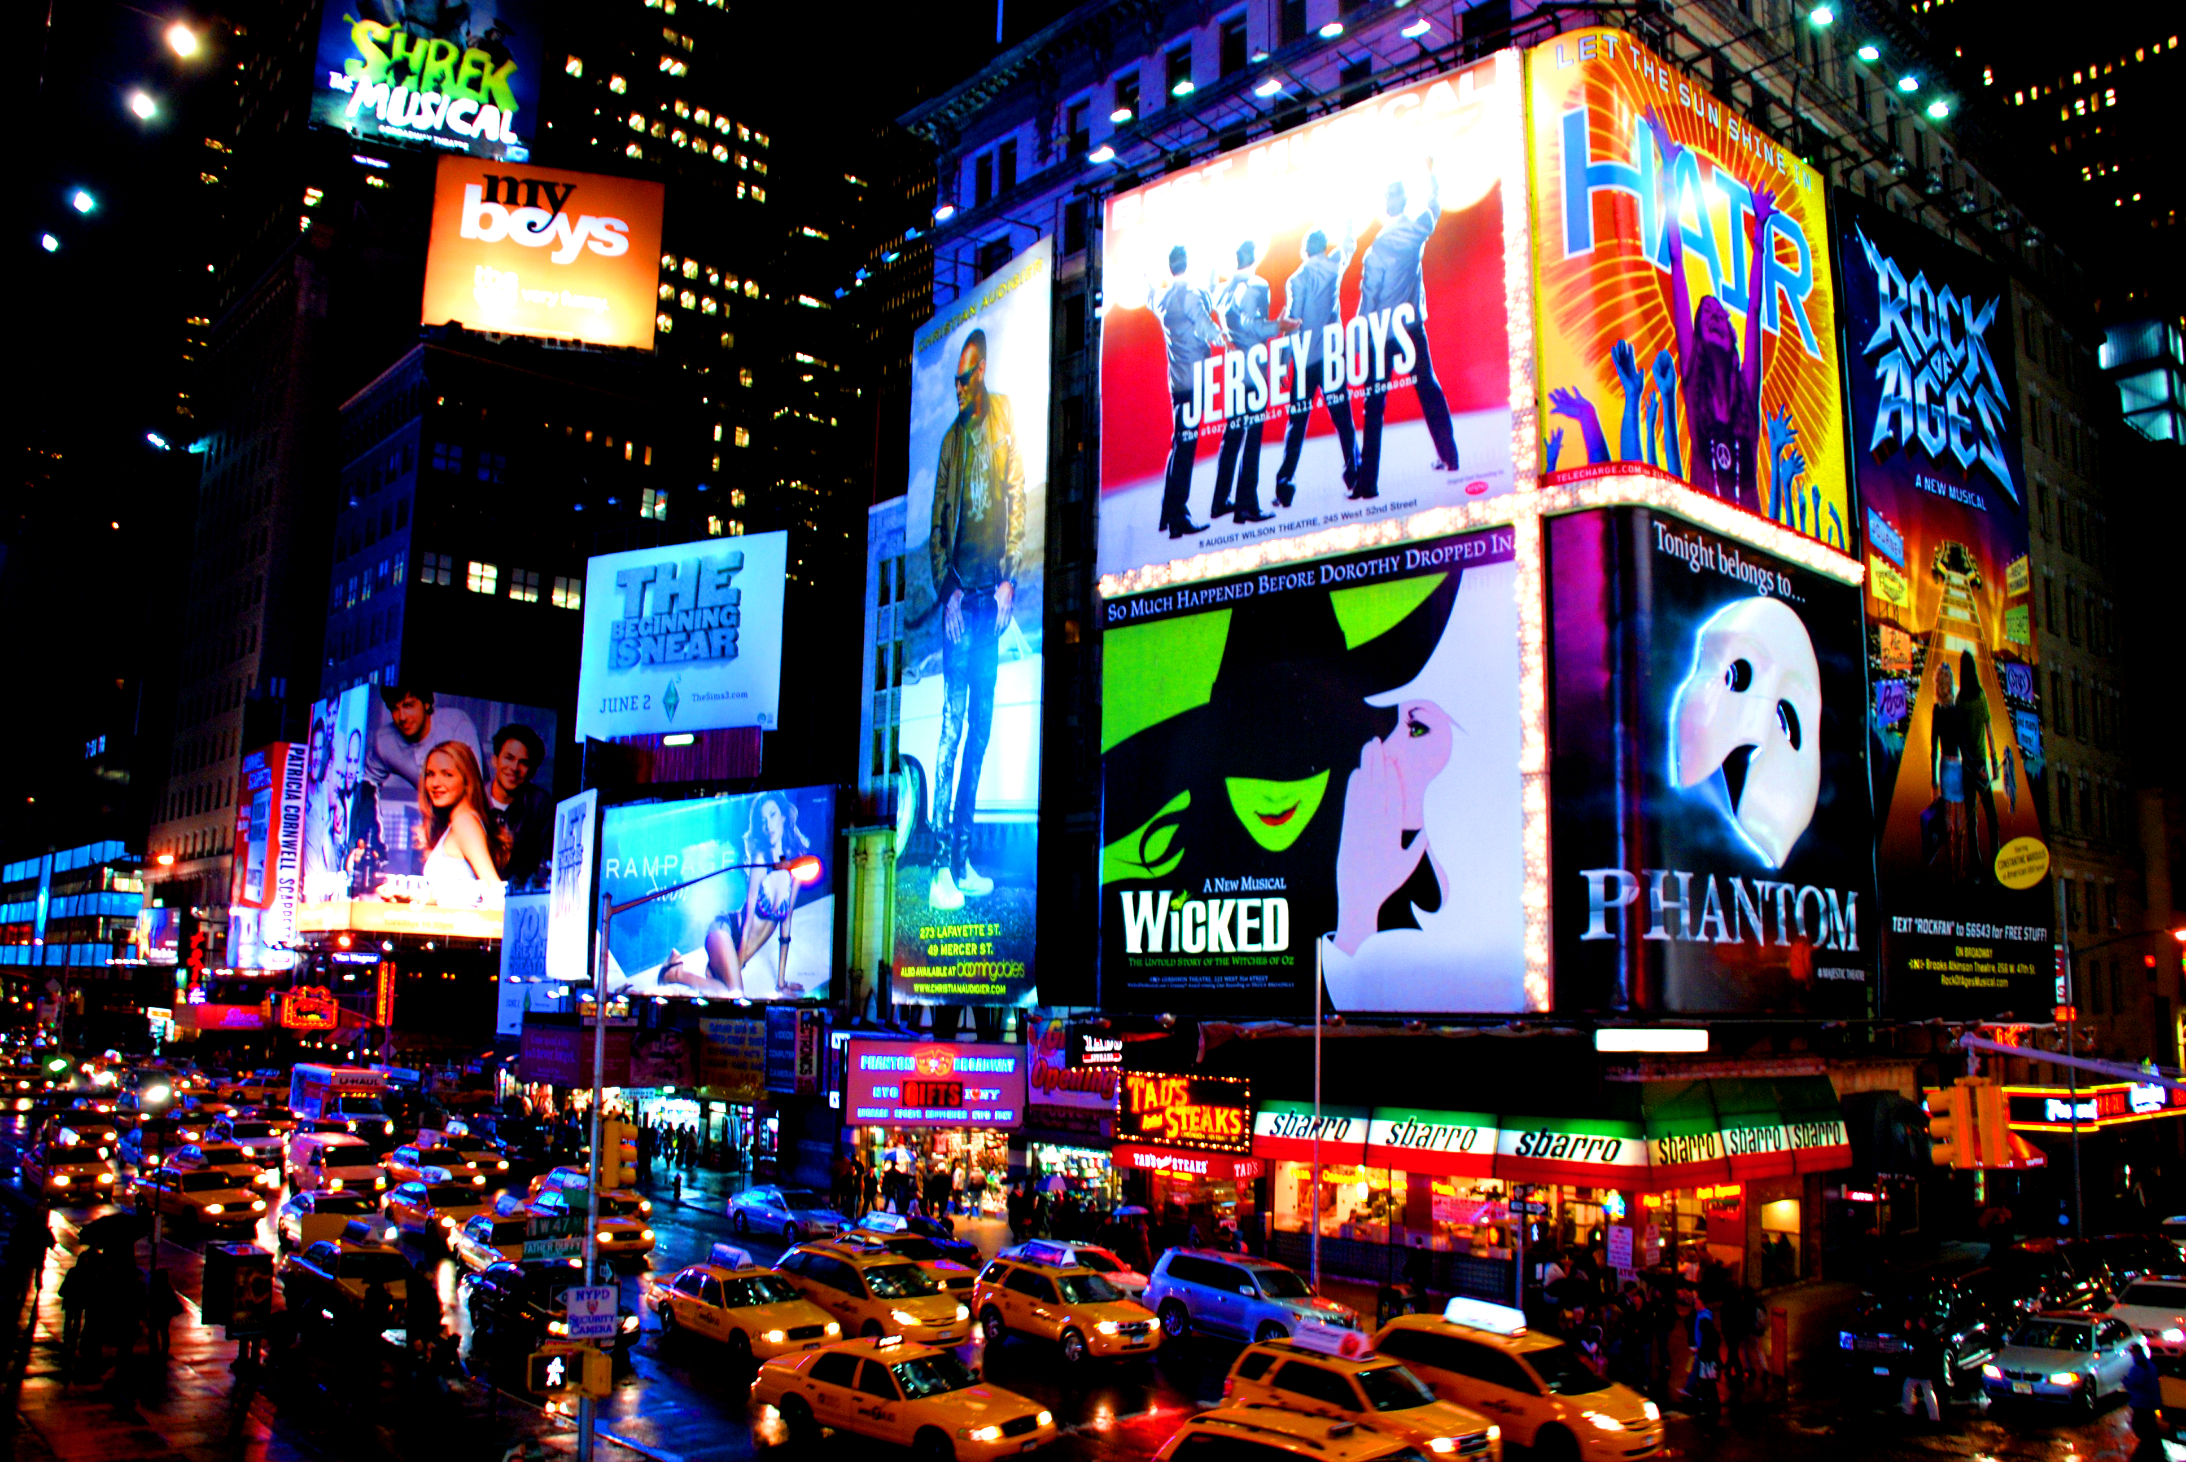
Document 2: Tourism industry in NYC

In 2013 New York City’s tourism industry posted another year of record-breaking growth. […] In New York City, all of us—whether we work in arts and entertainment, hospitality, dining, retail, meetings and conventions sales, the media or public service—together contribute to the City’s vibrancy. When tourists travel here, they do so to experience that unmistakable, one-of-a-kind New York City energy. Time and again, our diverse industry delivers the experiences that not only keep customers coming back but also support businesses, create jobs and generate billions of dollars in local economic activity for the benefit of all New Yorkers. In markets around the world, the message that New York City is safe, welcoming and more exciting than ever is reaching both our repeat visitors and potential new audiences. New partnerships—including those with Booking.com and Santander Bank—are helping us amplify that message and increase tourism in innovative ways. At the same time, cultural institutions that have long been integral to New York City’s identity and economy continue to prove a popular draw for people from around the world.

Emily Rafferty, Chairman, NYC & Company, March 14, 2014 – « Annual Summary – 2013 » www.nycgo.com

II. A CITY PLACED AT THE CORE OF GLOBAL NETWORKS

- A CITY AT THE HEART OF INTERNATIONAL DECISION-MAKING
Document 1: influential media based in New York City (www.crainsnewyork.com)
NYC-based media companies by 2013 net income:
Overall rank | Media company | 2013 net income (in thousands)
2 | 21st Century Fox Inc. | $7,323,000
4 | Time Warner Inc. | 3,691,000
5 | Viacom Inc. | 2,437,000
6 | CBS Corp. | 1,879,000
7 | Omnicom Group Inc. | 1,111,600
9 | Nielsen Holdings | 736,000
12 | News Corp. | 547,000
15 | AMC Networks Inc. | 290,160
16 | Interpublic Group of Cos. | 288,900
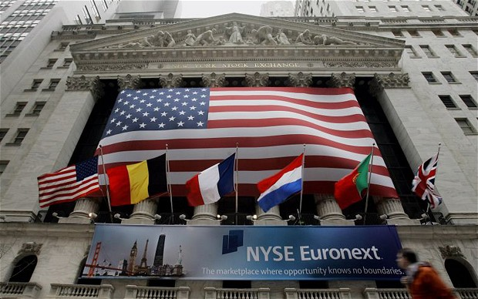
Document 2: International organizations based in New York

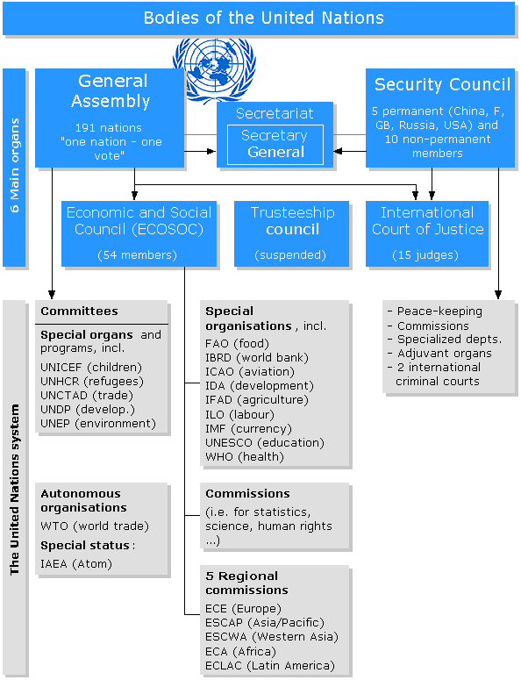

- A GLOBAL HUB

Document 1: World Trade Center Transportation Hub
The state-of-the-art World Trade Center Transportation Hub, when completed in 2015, will serve over 200,000 daily commuters and millions of annual visitors from around the world. At approximately 800,000 square feet, the Hub, designed by internationally acclaimed architect Santiago Calatrava, will be the third largest transportation center in New York City, rivaling Grand Central Station in size. In a joint venture with the Westfield Group, the Port Authority of New York and New Jersey will develop, lease and operate a major retail space at the WTC site, including in the Transit Hub. The WTC Transportation Hub's concourse will conveniently connect visitors to 11 different subway lines, the Port Authority Trans-Hudson (PATH) rail system, Battery Park City Ferry Terminal, the World Trade Center Memorial Site, WTC Towers 1, 2, 3, and 4, the World Financial Center and the Winter Garden. It will represent the most integrated network of underground pedestrian connections in New York City. (…)
Close-by to the Transportation Hub is the Vehicular Security Center and Tour Bus Parking Facility (VSC) construction project. As part of a comprehensive plan developed by the Port Authority, the VSC will be a state-of-the-art security screening checkpoint for all buses, trucks and cars accessing the WTC site and parking facilities.
Port Authority of New York and New Jersey, www.panynj.gov

Document 2: A rendering of the World Trade Center Transit Hub.

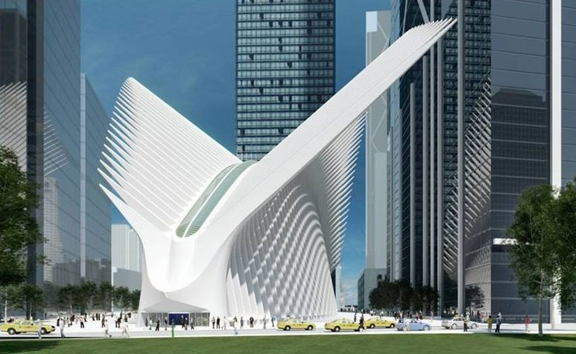

- A COSMOPOLITAN CITY
Document 1: Chinatown in 2013

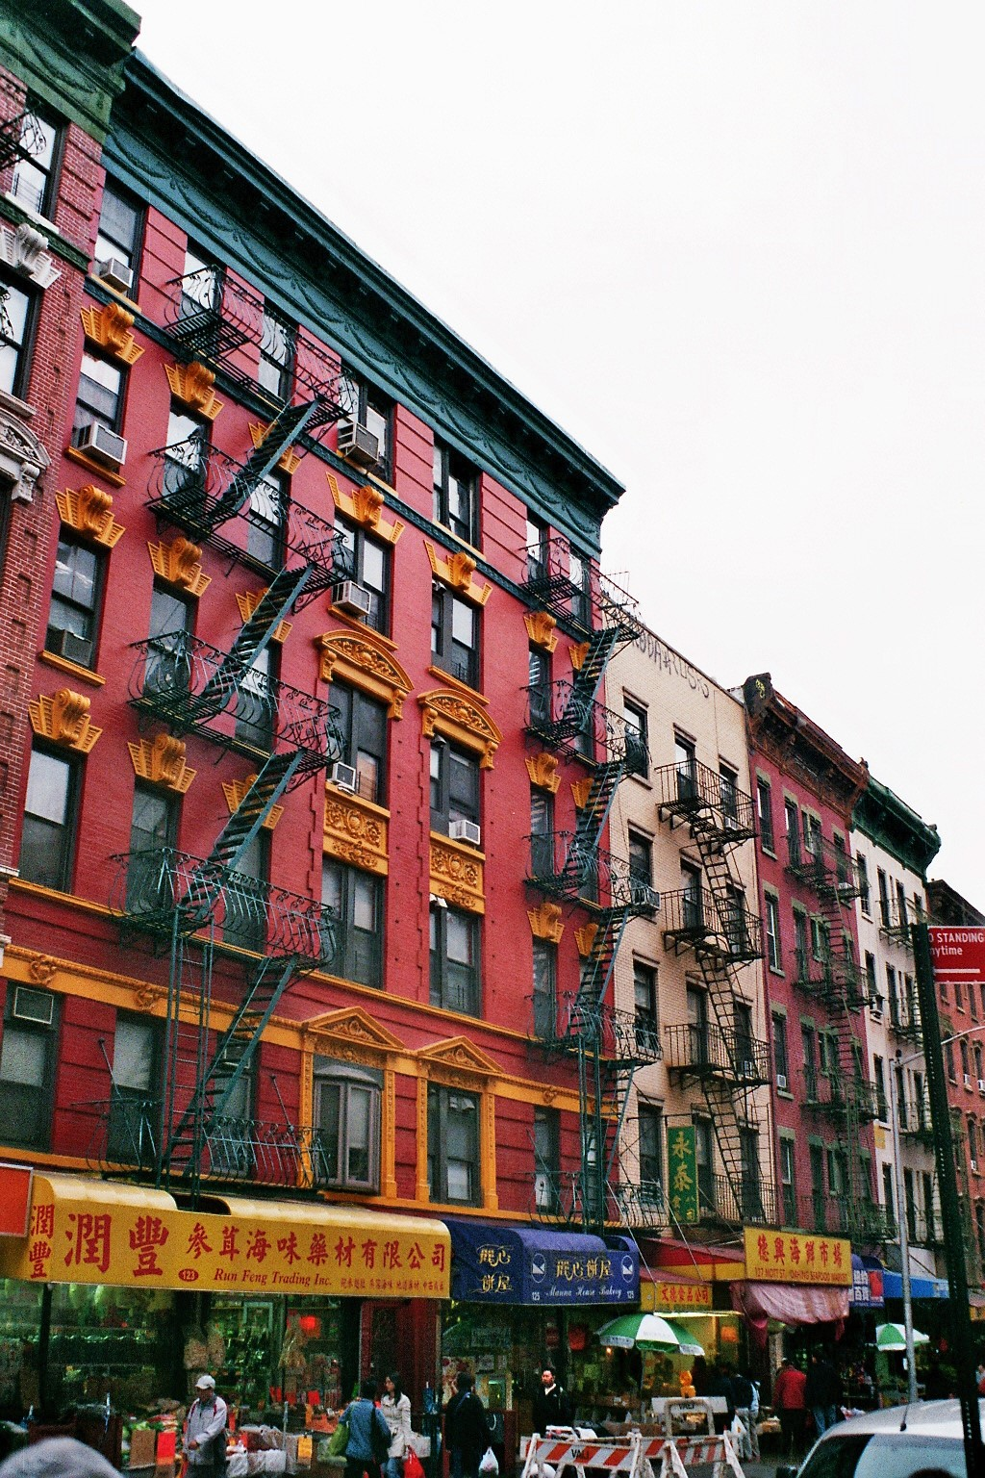

Document 2: Foreign students in New York

NYU welcomes applications for admission from students all over the world. In fact, international students, defined by NYU as students who do not hold citizenship or permanent residency status in the United States, comprise roughly 16% of the most recent entering class on our New York campus. There are, however, important notes for international students to consider when applying for admission:
Financial aid to international students on our New York campus is only available for incoming freshmen. If offered admission, international students will be required to submit a certification of finances demonstrating that they will be able to fund their four years of study through a combination of their own funds and any financial assistance we may provide. Students should not submit a certification of finances or bank statements until after they are offered admission. (…)
International students may be required to submit TOEFL, IELTS, or PTE Academic results as proof of English language proficiency.
New York University, “International Students”, www.nyu.edu
III. METROPOLITAN DYNAMICS RELATIVE TO THE INTEGRATION IN GLOBALIZATION PROCESS

- THE CENTRAL BUSINESS DISTRICT

Document 1: CBD employment
New York has the largest CBD in the nation by far, with nearly 2,000,000 jobs. Chicago's CBD (the Loop and North Michigan Avenue) has about one-quarter as many jobs (500,000) and Washington approximately 375,000. San Francisco, Boston and Philadelphia, also ranked among the nation’s transit "legacy cities," have between 200,000 and 300,000 jobs. Automobile oriented Houston and Atlanta are the largest otherwise, with Houston's downtown being much more compact than Atlanta's. Atlanta's downtown has expanded strongly (and less densely) to the north and includes "Midtown".
www.newgeography.com

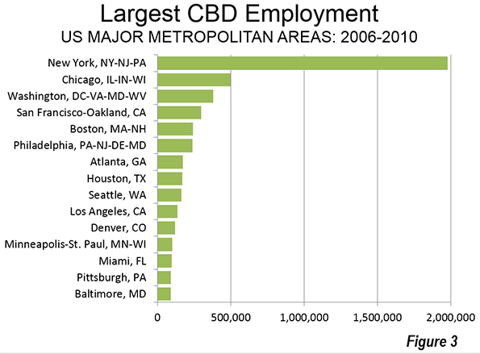

Document 2: Liberty tower, built on Ground Zero

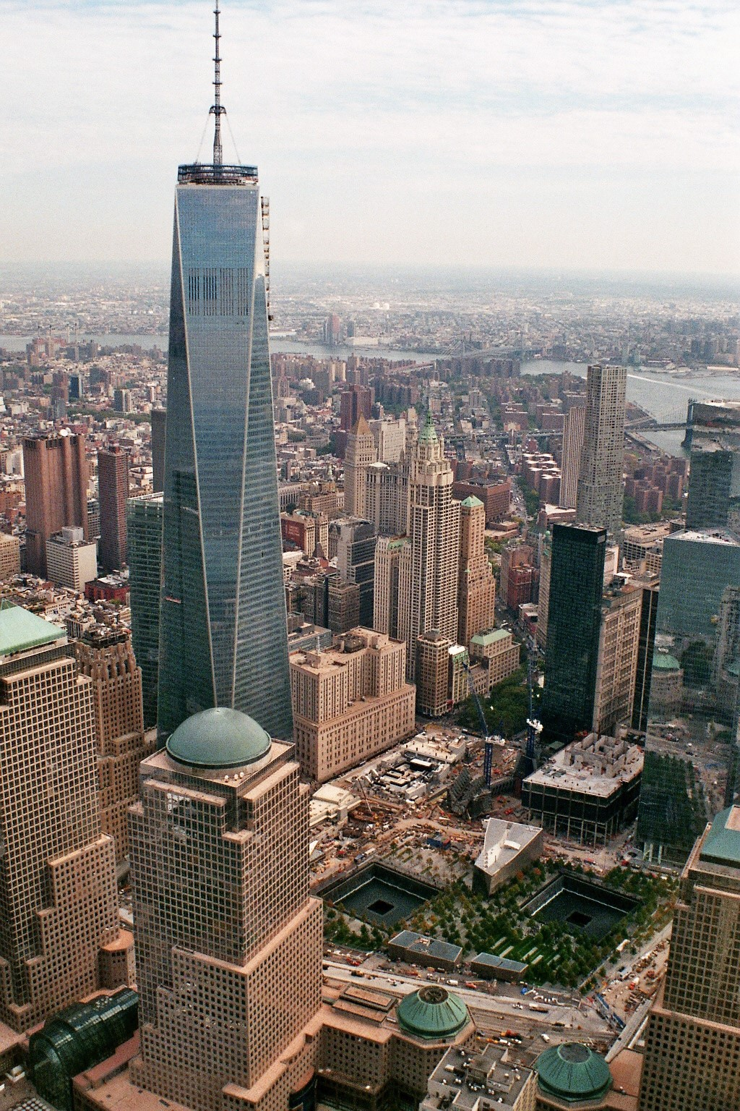

- SEVERAL SORTS OF SEGREGATIONS
Document 1: poverty in NYC (US Census Bureau 2006-10)

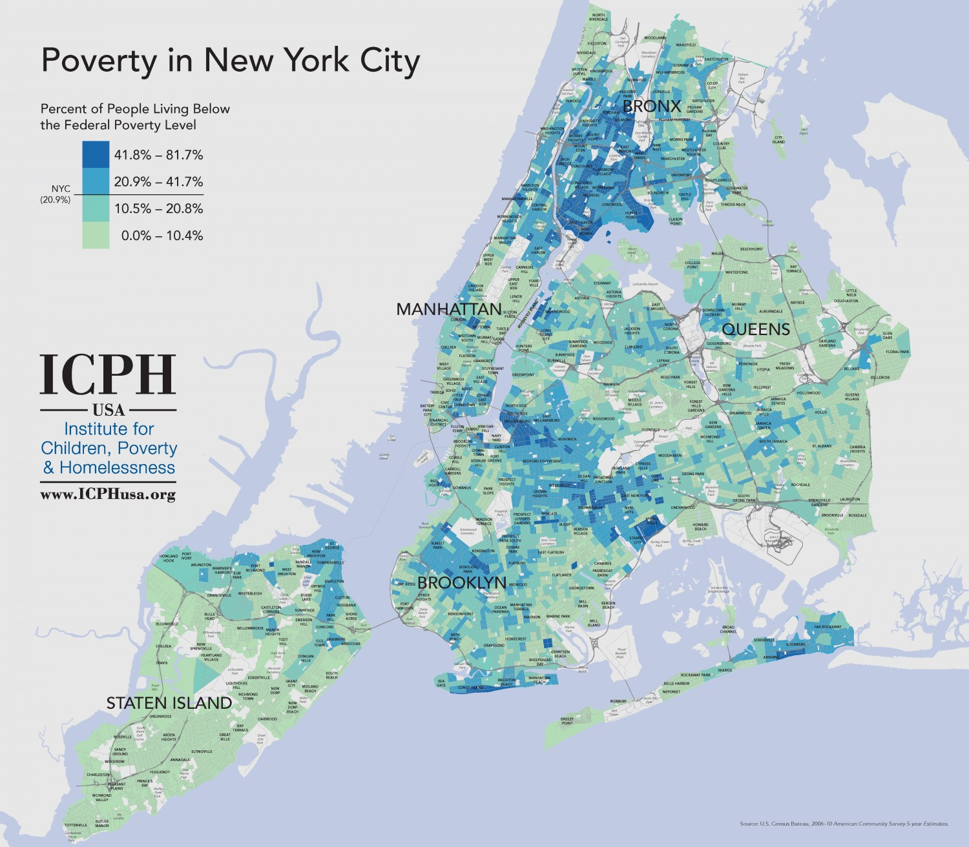

Document 2: How Segregated New York City Really Is
New York City may be one of the most diverse cities in the world, but it's also one of the most segregated cities in the United States. (…) The maps focus on "white-black segregation because that, for various social and historical reasons, has been by far the most significant geographic separation in American cities, certainly in the Midwest and Northeast."
"New York’s segregated neighborhoods form a more complex patchwork across the city. That means that while a North Sider in Chicago might go years without having to even pass through a black neighborhood, lots of white New Yorkers have to get through the non-white parts of Brooklyn or the Bronx to reach job and entertainment districts in Manhattan or northern Brooklyn." (…) Many people were shocked by last month's Civil Rights Project report on school segregation. The report found that New York City has the most segregated schools in the country. Of the city's 32 Community School Districts, nearly 20 had 10 percent or fewer white students in 2010. The report also calls most of the city's charter schools "apartheid institutions," as white students make up less than one percent of students at 73 percent of city charter schools.
The Huffington Post, by Christopher Mathias, April 15, 2014
- ENVIRONMENTAL CONCERNS
Document 1: Citibike in New York – “green transports for rent”

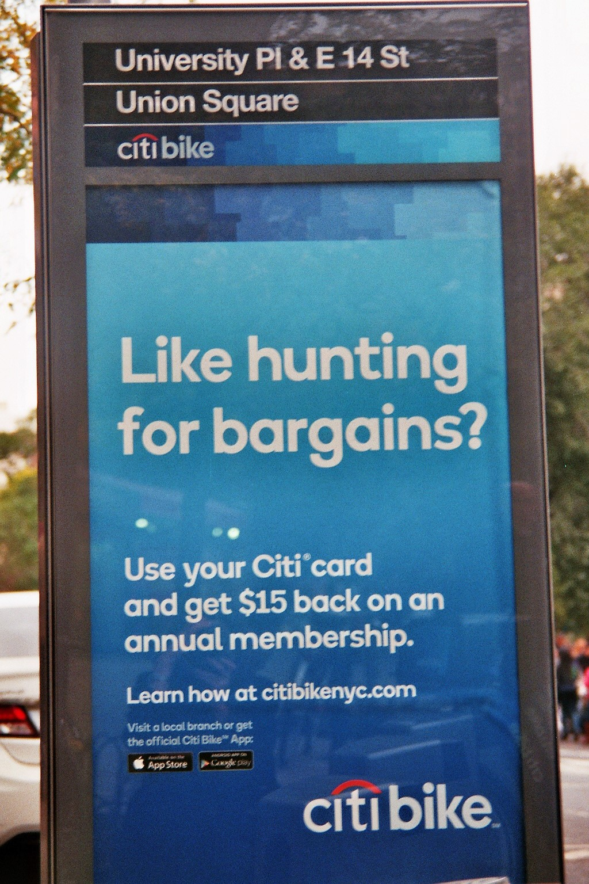

Document 2: A More Sustainable New York and MTA

New York State has the lowest per capita energy consumption and greenhouse gas emissions in the United States, and it’s mostly because of public transit. (…)
But all the environmental improvements we’re making are just a drop in the bucket compared to what we do for our environment every single day. In fact, every year, the MTA allows our region to avoid almost 17 million metric tons of greenhouse gas emissions. That’s equal to more than three times the entire annual greenhouse gas emissions of San Francisco.
Our mass transit network isn’t the only reason New York is so environmentally friendly. People also need to want to use it. It needs to work well and be reliable enough to get people where they need to go—safely and on time, every day. That’s why—if you want to invest in the sustainability of our region—the best way to do it is by supporting the investments that maintain and improve our entire system: the MTA’s Capital Program.

www.web.mta.info - MTA Capital Program 2015-2019, As Proposed to the MTA Board September 24, 2014
CONCLUSION: Fighting the final phases of gentrification in New York?

NEW YORK, NY – « In January, the Department of Housing Preservation and Developments released a proposal of city-owned sites for housing developers to build on. Around 16 of these sites contain community gardens that are in predominantly low-income, black and Latino neighborhoods. » (www.argusnewsnow)

