INDUSTRIALIZATION AND EUROPEAN EXPANSION

INTRODUCTION: industrialization and world-economies

British and European Industrialization
Modern economic growth – the simultaneous increase in population and average incomes – has been capitalism’s greatest achievement. This growth first became apparent in Britain in the nineteenth century and then spread to continental Europe (and the United States). The process is usually associated with the Industrial Revolution in Britain and the spread of British-type industrialization to follower economies. This chapter reviews the emergence of modern economic growth and suggests that the usual view is misleading in that it focuses is too limited both in time and in the technological change it usually emphasizes. On one hand, the of famous industries – textiles, iron and engineering – contributed only modestly to growth because they constituted only a small proportion of the economy. Furthermore, the emergence of growth was much more gradual than traditionally understood. In new views, Britain was already a substantially industrialized economy with relatively high wages before the early eighteenth century. The origin of growth appear to lie in the ability of an economy in which both product and factor markets were well developed in both the rural and urban areas to partially overcome Malthusian constraints. The spread of growth to continental Europe is often seen as the spread of new technology of the British Industrial Revolution. This too seems somewhat misleading. The industries were small relative to the entire economies and their success depended on particular conditions. Furthermore, just as Britain’s early success rested importantly on productive capitalist agriculture, the emergence of increased incomes on the continent depended on agricultural reforms that increases in its productivity.
C. Knick Harley, University of Oxford – Department of economics – www.economics.ox.ac.uk

I. INDUSTRIALIZATION AND ECONOMIC GROWTH IN GREAT BRITAIN
A. THE AGE OF INDUSTRIALIZATION
Doc 1: Third-class passengers at an underground railway station by Gustave Doré from London: A Pilgrimage. 1872.

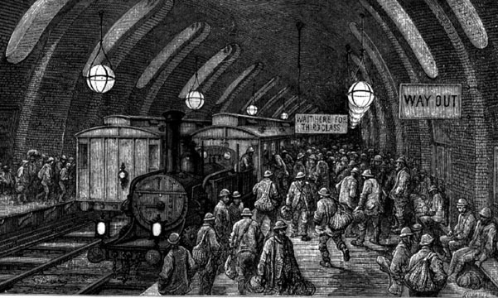
Doc 2: Chronology of industrialization www.sscnet.ucla.net
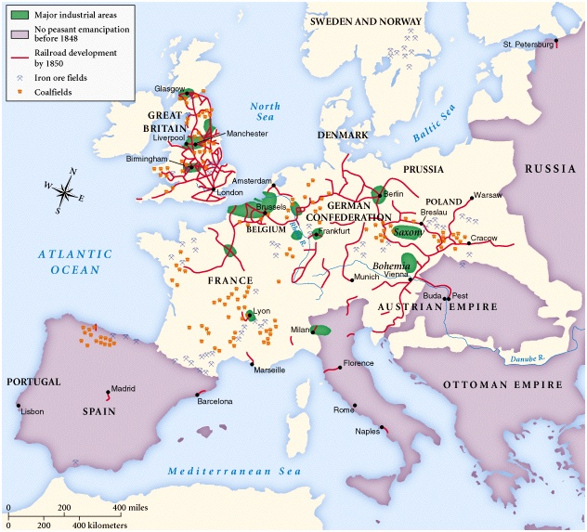
www.sscnet.ucla.net chronology of industrialization
B. THE EVOLUTION OF ECONOMIC GROWTH
Doc 1: “Cottonopolis”, engraving by Edward Goodall (Manchester, 1840)
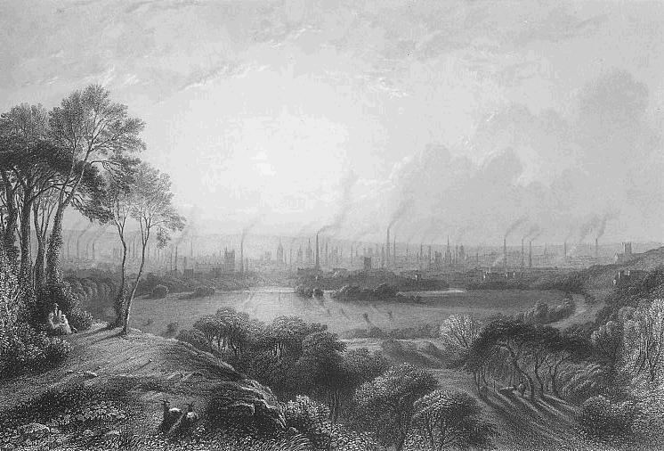
Doc 2: Tables on demographic evolutions in UK

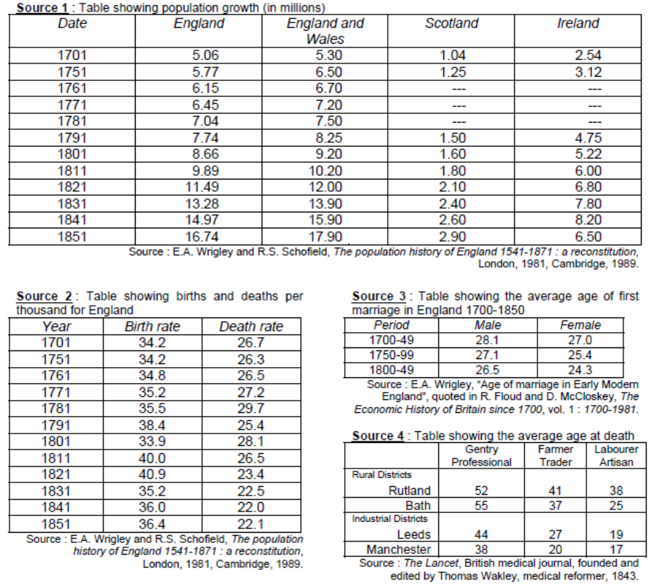
II. SOCIAL AND POLITICAL MUTATIONS DURING THE VICTORIAN AGE

- A WORLD OF CONTRASTS
Doc 1: A chronic condition of misery

It will be readily apparent to the reader that I saw much that was bad. Yet it must not be forgotten that the time of which I write was considered "good times" in England. The starvation and lack of shelter I encountered constituted a chronic condition of misery which is never wiped out, even in the periods of greatest prosperity.
[…]
Society grows, while political machines rack to pieces and become "scrap." For the English, so far as manhood and womanhood and health and happiness go, I see a broad and smiling future. But for a great deal of the political machinery, which at present mismanages for them, I see nothing else than the scrap heap.

Jack London, The People of the Abyss, Preface, 1903.

Doc 2: Photograph of match makers at the end of the 19th century: children involved in this process often suffered a horrible disease from breathing phosphorous. (Taken from the Daily Mail, 17 September 2010)

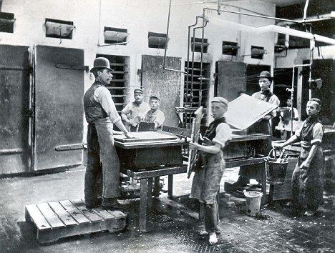

- SOCIAL REFORMS AND THE RISE OF THE LABOUR MOVEMENT
Doc 1: A Socialist point of view on the Victorian age
Before the uprising of modern Socialism almost all intelligent people either were, or professed themselves to be, quite contented with the civilization of this century. Again, almost all of these really were thus contented, and saw nothing to do but to perfect the said civilization by getting rid of a few ridiculous survivals of the barbarous ages. To be short, this was the Whig frame of mind, natural to the modern prosperous middle-class men, who, in fact, as far as mechanical progress is concerned, have nothing to ask for, if only Socialism would leave them alone to enjoy their plentiful style. […]
Apart from the desire to produce beautiful things, the leading passion of my life has been and is hatred of modern civilization. What shall I say of it now, when the words are put into my mouth, my hope of its destruction—what shall I say of its supplanting by Socialism?
William Morris, “How I became a Socialist”, Justice, June 16th, 1894.

Doc 2: The Dock (Workers) Strike in Punch Magazine, by John Tenniel (14th September, 1889)
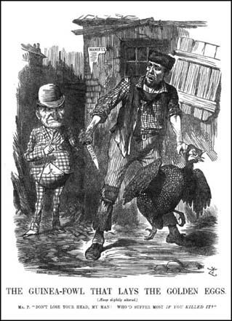
III. THE AGE OF EMPIRES – world-economies and globalization

- ESTABLISHING THE BRITISH EMPIRE
Doc 1: the British Empire in 1815
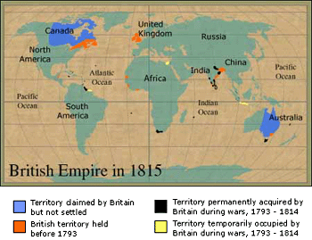
Doc 2: the British Empire in 1922
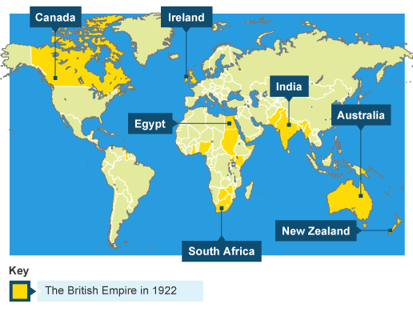
- THE UK AS A WORLD-ECONOMY
Doc 1: Establishing a world-economy since the end of the eighteenth century
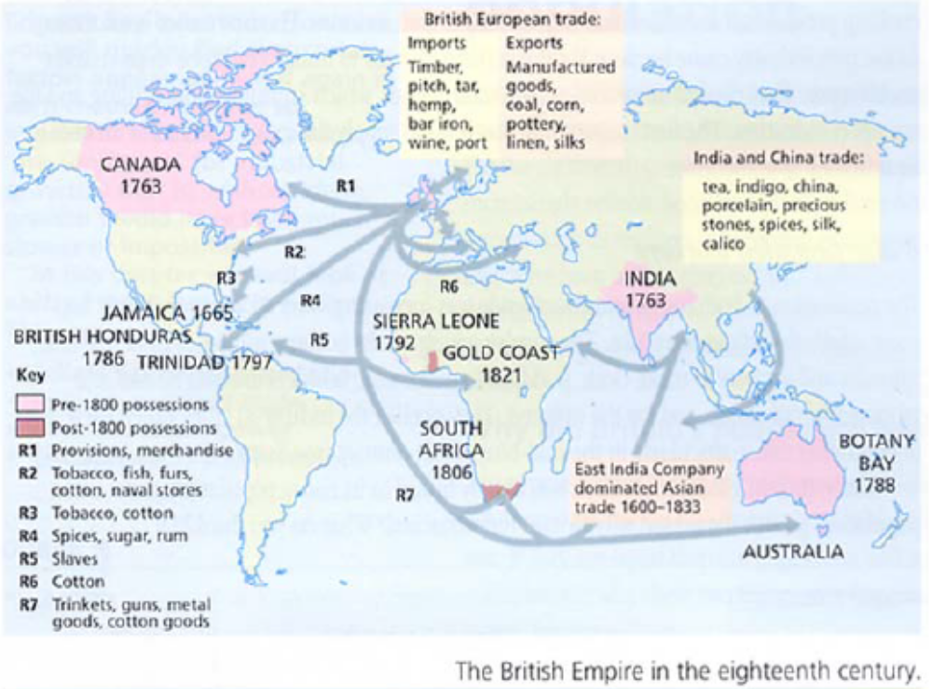
Doc 2: Evolution of imports and exports during the nineteenth century
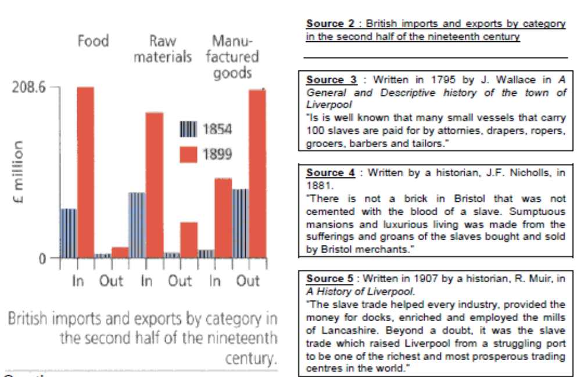
CONCLUSION: Birth of a new world order

