BRITISH MEMORIES OF THE HOLOCAUST

Over the course of the war, the Jewish Agency tried persuading the British to help it send commandos from the yishuv into occupied territory, where they could set up Jewish underground groups to fight the Nazis. The agency pictured about a thousand men. At least they could try to sabotage the railroads to the death camps. Ben-Gurion had no faith in the idea: “Jewish commandos in the war in Poland is ludicrous ! If you want to have commandos, you have to have a state,” he ruled. The British rejected it for various reasons: they did not believe that such an operation would advance the war effort; they did not want to enhance the Jewish Agency’s power; they did not want to be indebted to the agency. All such proposals were rejected or lost in bureaucratic channels.
Tom Segev, The Seventh Million, The Israelis and the Holocaust, 1991. Translated by Haim Watzman in 1993.

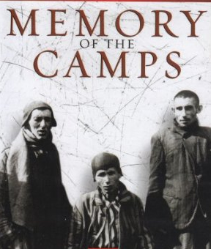
Poster for a British documentary on the liberation of the camps (1985).

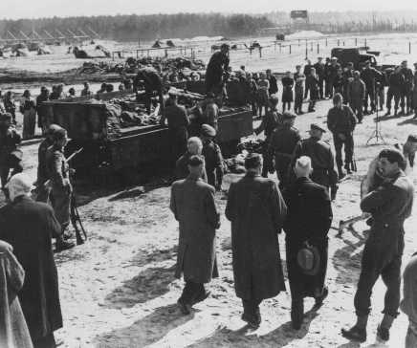
After liberation of the Bergen-Belsen camp, British soldiers forced German mayors from nearby towns to view mass graves. Bergen-Belsen, Germany, after April 15, 1945.
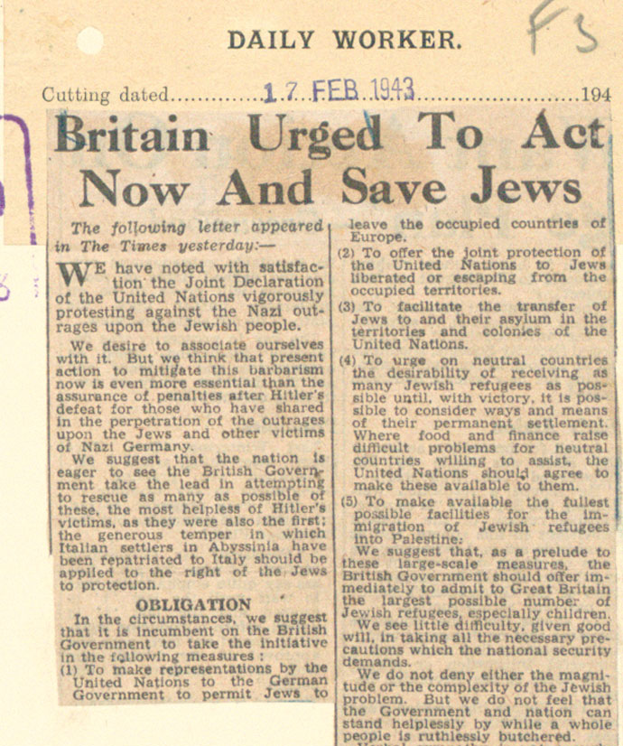

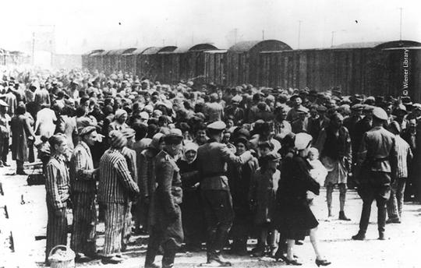
Selection at Auschwitz – Holocaust Memorial Day Trust (www.hmd.org.uk)

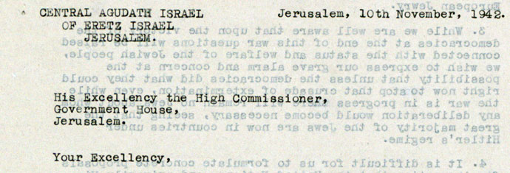
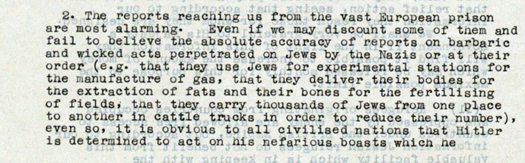
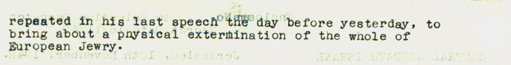
Extract from a letter written by a representative of the Jewish community in Jerusalem to the British High Commissioner in Jerusalem, November 1942 (www.nationalarchives.gov.uk)

